APAD Universal Credit Working Group Newsletter
February 2019

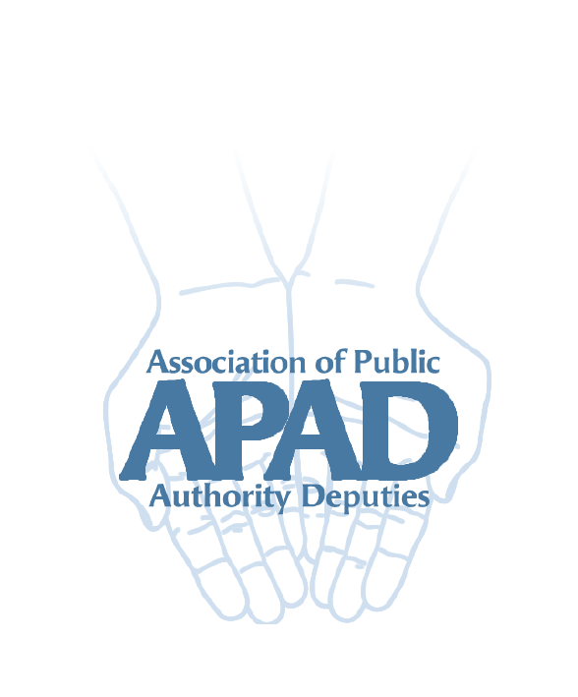

Introduction
Universal Credit updates
- Severe Disability Premium Gateway
- Mixed age couples
- Further delay to managed migration
UC Payments and National Insurance numbers
New APAD website

Introduction
Welcome to the second newsletter of the APAD Universal Credit working group. In this newsletter we give the latest DWP updates and have a look at some of the issues raised at the working group meeting last month.

Universal Credit updates

The Severe Disability Premium (SDP) Gateway
New regulations mean that from 16 January 2019 an “SDP entitled person” cannot make a new claim for Universal Credit (UC) even if they have a change of circumstances which would otherwise have meant a UC claim.

This means they can make a new claim for a legacy benefit.

An “SDP entitled person”
This means a person who:
- gets a legacy benefit which includes the severe disability premium; or
- the legacy benefit ended in the previous month and they continue to satisfy the conditions for the premium
It includes couples where both are entitled to the premium.

Who is entitled to a severe disability premium?
The severe disability premium is an additional amount of £64.30 included in legacy benefits where certain conditions are satisfied. These are:
- The claimant gets either:
  - The daily living component of Personal Independence Payment at either rate; or
  - the middle or higher rate of the Disability Living Allowance care component; or
  - Attendance Allowance
There are other, less common, qualifying disability benefits – seek advice.
- They live alone. This means there are no non-dependants aged 18 or over normally residing with them
- No one gets Carer’s Allowance for caring for them (seek advice about this)

Legacy benefits
- Income-related Employment and Support Allowance
- Housing Benefit
- Income Support
- Income-based Jobseeker’s Allowance
- Child Tax Credit
- Working Tax Credit

Compensation for those already on Universal Credit who have lost the premium
The severe disability premium is not replicated in UC. Some people who migrated to UC before 16 January have therefore lost money. There is a proposal in further regulations (which have not yet come into force) to partially compensate these people.

This may change before it becomes law – we will include further updates in future newsletters and on the new APAD website (see below).

“Mixed age” couples and Universal Credit
At the moment ‘mixed age’ couples, where one person is State Pension age and the other person is younger than that, can choose whether to claim Pension Credit or Universal Credit. Usually, Pension Credit is more generous.

The new regulations provide that from 15 May 2019 this will change for new claimants. To be entitled to Pension Credit, both adults will have to be of State Pension age. Otherwise they will have to claim Universal Credit.

The regulations also provide that mixed age couples who are already in receipt of Pension Credit or pension-age Housing Benefit at the point of change will be unaffected while they remain entitled to either benefit.

Further delay to managed migration
Managed migration is the DWP term for the process of telling people on legacy benefits that they have to claim Universal Credit. The start of this has been delayed many times.

The government now propose a pilot to “support 10,000 people through the process” from July 2019. Once 10,000 UC awards have been made there will be a halt while DWP looks at what they have learned from the pilot.

At this point no there is no information about how the 10,000 will be chosen for the pilot. Check the website for further updates.
The timescale for the start of full managed migration keeps changing. It is currently due to start some time in 2020 and finish at the latest by 2024.

Universal Credit payments and National Insurance numbers
A major issue with Universal Credit for corporate appointees is the lack of an appropriate identifier on UC payments. For some teams this means a lot of time and effort is needed to track which client a payment is for.

Our previous newsletter mentioned The Universal Credit Local Authority Bulletin UC3/2018
which confirmed that National Insurance numbers would be shown on the payment schedule by the end of 2018.

It appears that this is very inconsistent in practice and APAD members are reporting that while they may have received one or two payments with a NINO they are also still getting payments with an apparently random identifier.

We have asked a contact to raise this with the operational stakeholders group. In the meantime please let us know if you are still receiving payments without a NINO reference. You can either email us at apadunicredit@gmail.com or via the new website (see below).

New APAD website
The New APAD website is now Live (Apad.org.uk) and has a new “Universal Credit and other Benefits section” where you can find the latest news on Universal credit and other useful benefit information. If you have any problems accessing the site use the Contact Us button on the front page which is being actively monitored.

Aims of the Universal Credit working group
The aims of the group are:

- To provide advice and support and regular updates to the membership regarding Universal Credit.
- To gather useful information, solutions and contacts and share this with the membership via the Newsletter and occasional emails.
- To liaise with the DWP on behalf of APAD regarding our issues with Universal credit and use APAD members’ experience to encourage DWP to adopt consistent and better working practices with corporate Deputies and appointees.
- To develop national contacts with the DWP (and other organisations) for APAD with regard to Universal Credit.

Your feedback
The working group would really like to know about issues are affecting your team with regard to Universal Credit. We would also like to hear about of good practice and solutions that teams may have found that we can share with the membership.

You can email us at apadunicredit@gmail.com or via the new website.

