APAD Universal Credit Working Group Newsletter
June 2020
Coronavirus (Covid 19) Special

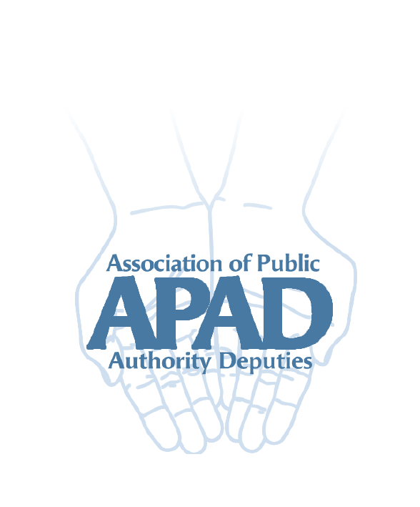

Introduction
Benefit phone lines
Universal Credit
Employment and Support Allowance
Disability benefits
Fit notes and assessments

Introduction
This newsletter gives a round up of the latest arrangements for benefits during the Coronoavirus (Covid 19) crisis.

Benefit phone lines
Benefit phone lines for new claims and helplines for existing claims have reduced hours and are generally very busy. Most are open from 9.30am to 3.30pm Monday to Friday.

Pension Credit and disability benefit phone lines are still open 9am to 5pm Monday to Friday.

The line for Carer’s Allowance is now open only between 10am and 2 pm Monday to Friday.

Universal Credit
There have been nearly 3 million new claims for UC since the government instituted lock down rules. Many other DWP departments have had staff temporarily relocated to UC to deal with these. As a result for most benefits, processes have been adapted.

New claims can be made and should be made online if possible. The UC Helpline is extremely busy.

If you have an arrangement to provide ID documents by email you can continue to do so.
No-one is required to attend a jobcentre.

For existing claims you can continue to use the account as normal to report changes of circumstance and use the Journal to post queries, request a mandatory reconsideration and so on.

The standard allowance was increased by around £20 a week from 6 April for all claimants. You will have started to see the increased payments from 12 May. The increase is for 12 months only.

See below for information about fit notes and capability for work assessments.

NB When you log in to a client’s UC account you should now see a red box about Coronavirus with a link to a list of FAQs about the current arrangements.

Employment and Support Allowance
Claims for new style contribution based ESA can now be made:
- Online for those not already getting Universal Credit
- By posting a message on the UC Journal for those who are on UC

The online claim is here: https://www.apply-new-style-employment-support-allowance.dwp.gov.uk/eligibility-start. Please note the information from gov.uk says you cannot use the online claim if you are an appointee. However there seems to be nothing in the online process that prevents you from using it to make a claim. You can then let ESA know you are appointee. If you do not use the online claim you need to phone the UC helpline to start the claim.

Income related ESA awards should be continuing as usual as should other legacy benefit awards.

See below for what to do about fit notes and ESA50 forms.

Disability benefits
Although the government announced at the start of lockdown that all awards of disability benefits due to end would be extended it now appears this is not the case. There are different processes for the different disability benefits.

Attendance Allowance
A new claim can still be started by phoning the AA Unit – now open 10 till 2 Monday to Friday. As AA cannot be backdated don’t delay making a claim now.

We understand that all existing Attendance Allowance awards that are due to end will be extended to indefinite awards. But these may be reviewed again at some point.

No face to face assessments are taking place for new claims but the claimant may have a paper based or telephone assessment. A telephone assessment will be notified in writing to you. It is important that the claimant takes part in any telephone assessment.

Disability Living Allowance
New claims can be made for those under 16 and will be processed. DLA claims cannot be backdated so don’t delay making a claim.

Awards for young people turning 16 will be extended and they will not be invited to claim PIP until things go back to normal.

DLA awards for adults which are due to be reviewed should be extended.

Personal Independence Payment
New claims for PIP can still be made and will be processed. PIP2 “How your disability affects you” forms are being sent out and should be returned as soon as possible. Return dates have been extended to 12 weeks from the date the PIP2 is sent for now.

No face to face assessments are taking place but the claimant may have a telephone or paper based assessment. You should be notified in writing about the date and time of any telephone assessment. It is important that claimants take part in a telephone assessment. They can have support from a carer, support worker, friend or relative.

Existing PIP awards that are due to be reassessed under the “planned intervention” process should be automatically extended. A planned intervention is one that is initiated by PIP, for example where the award letter says “we will contact you after” a specific date.

An “unplanned intervention” is where a review happens because the claimant (you as appointee) notifies a change of circumstances that might affect the level of the award. A PIP2 form will be sent out and if it is not returned within the time limit and PIP do not accept there is a good reason for this the award will terminate. It is therefore vital that any PIP2 forms sent as part of this process are completed and returned as soon as possible. If it is not possible to return the form within the time limit due to Covid restrictions, contact PIP and request a further extension of time. For example, if a care manager is unable to visit the claimant to complete the form.

Fixed term PIP awards. These are awards with a set end date which do not state that PIP will contact you to make a new claim. We understand these awards may not be automatically extended. If not any such award will terminate on the end date. We would advise checking if you have any clients with this type of PIP award. If so the safest thing to do is contact PIP for advice as to whether to make a new claim and if so when. This should avoid the situation where the award ends before a decision is made on a new claim.

Fit notes and work capability assessments for ESA and Universal Credit
Fit notes:
- for Universal Credit can be reported through the online account as normal. They do not need to be sent or taken to a jobcentre (which are closed)
- for new style contribution based ESA can be reported online as normal
- for income related ESA can be posted to ESA. Although ESA have said there is no need to do this at the moment and no-one will lose their ESA if fit notes are not sent, we would advise posting them anyway. If you are not sending them you should keep hold of them until ESA asks for them.

ESA50 and UC 50 forms
We originally advised that these did not need to be completed and returned. We now have new, recent information from DWP about assessments (see below).

As a result our advice now is that you should get ESA and UC50 forms completed and return them, if possible. You may get a decision as a result (see below). Even if you do not get a decision we think there may be fewer delays if you return them now rather than waiting for the Covid restrictions to end.

Assessments
No face to face assessments are being held. The most recent information is:

- ESA50s and UC50s are being sent by DWP to the Centre for Health and Disability Assessments (CHDA) and processed by them
- CHDA health professionals are carrying out paper based and telephone assessments where possible.
- If the claimant meets the criteria for the support group based on the assessment, the claim is returned to the decision maker with that recommendation.
- If the claimant does not meet support group criteria CHDA says the claim “goes back in the queue” to wait for an assessment.
- Telephone assessments can be recorded if the claimant requests it.
- Special rules claims (for those who are terminally ill and have a DS1500 form) should be decided on the papers unless the health professional feels further evidence is required.
- Those who do not get a support group decision under this process are likely to be contacted “in the coming months” for a telephone assessment (statement from Justin Tomlinson a DWP Minister on 4 June).

Further supporting evidence can be emailed directly to customer-relations@chdauk.co.uk.
This could help them make a paper decision.

Updates
Information from DWP has at times been confused and conflicted depending on its source. We will try to keep up with any changes to benefit administration and add them to the website when possible.

Your feedback
The working group would really like to know about issues that are affecting your team with regard to Universal Credit or the Covid 19 situation. We would also like to hear about good practice and solutions that teams may have found that we can share with the membership.

You can email us at apadunicredit@gmail.com or via the APAD website.

In the meantime stay safe!

