APAD Universal Credit and other benefits newsletter
September 2020
Coronavirus (Covid 19) update and miscellaneous news

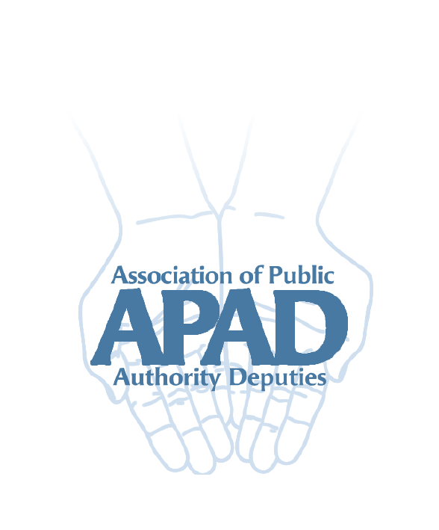

Introduction
Fit notes
Sickness and disability benefit assessments
Telephone assessments
Deductions from benefits
Legacy benefit run on
SDP Gateway removed next year

Introduction
Welcome to the latest newsletter, hoping everyone has stayed safe and well to date. In this newsletter we give an update on changes to the processes which were introduced during lockdown. Plus a few bits of general benefit news.

Fit notes
DWP say you must now provide fit notes for new ESA claims from the 10 July. For claims made before that date, DWP will write to tell you what date you need to provide a fit note from.

New UC claims on sickness grounds now require a fit note after the first 7 days. You can report these through the Journal and post or email them to the jobcentre.

Latest on assessments for disability and sickness benefits
There have been numerous and confusing announcements about these. To sum up:

- ESA50s and UC50s are now being sent out again. This is for new claims and to cover the backlog due to Covid arrangements. So you might be getting a lot of these over the next few weeks.
- The return time for ESA50s and UC50s is the usual 28 days. The Centre for Health and Disability Assessments (CHDA) does not give extensions for these forms. If you think you will not be able to return it within the time, contact ESA or UC to let them know. Provided they accept there is a good reason for the delay, your client’s benefit will not stop.
- PIP2 forms continue to be sent out for new claims. PIP review forms are now being sent out again. No further extensions to existing claims will be given.
- The return time for PIP forms is the usual month. PIP will usually agree a 2 week extension.
- Face to face assessments:
  - Atos and Capita are not carrying out PIP face to face assessments yet. They are continuing with telephone assessments.
  - CHDA is not carrying out face to face assessments. They are also carrying out telephone assessments for ESA/UC. They say if they are unable to complete a telephone or paper assessment the claimant will have to wait for a face to face assessment. There is no information yet as to when these will be resumed.

Telephone assessments
PIP telephone assessments
You are entitled to 7 days’ notice in writing for a PIP telephone assessment; however in our experience this is not always given. Our clients are likely to need support for a telephone assessment. If this support is from a professional such as a care manager or support worker they may not be available at short notice. If so it is important you contact the assessment provider to explain this and that you require the proper notice. If you have any claims referred back to PIP because your client “failed to attend” a telephone assessment, make a complaint to the assessment provider (AP) and contact PIP to explain the circumstances. This will hopefully avoid any claims being turned down. If they are, challenge the decision.

Atos and Capita will arrange a conference call with the client and support worker/care manager if necessary. We have found that calls are not always made at the appointed time or even at all in some cases. Again it is important to contact Atos or Capita to let them know and arrange another appointment.

Most assessors continue to work from home so clients and support workers need to be aware the call may come from an unrecognised mobile number or a withheld number.

It is useful for the client and/or support person to have a copy of the most recent PIP2 or review form to hand for an assessment. Guidance is clear that a companion or support worker can give information on the client’s behalf or assist them to answer questions. If the assessor refuses to allow this, complain.

Note if the AP intends to carry out a paper based assessment they may contact you or one of the professionals named on the PIP form for further information. They should not contact the client direct. These phone calls are usually made without any notice given and should last a few minutes only; they do not constitute a telephone assessment. If the AP is unable to carry out the paper assessment following such a call they should arrange a formal telephone assessment.

ESA and UC telephone assessments
The Centre for Health and Disability Assessments (CHDA) have produced some information about telephone assessments here: https://www.chdauk.co.uk/information-about-telephone-assessments.

The same considerations apply about notice periods and having someone to support the client as for PIP.

If the assessor is unable to complete a report from a telephone assessment this does not mean the client will be found fit for work. CHDA must arrange a face to face assessment in these circumstances. No face to face assessments are taking place yet so this could mean a lengthy wait for some clients. And they will also be stuck on a basic rate of either benefit. In addition, new style contribution based ESA stops after 365 days unless the claimant is assessed as meeting support group conditions.

A claimant can be assessed as fit for work from a telephone assessment if a full assessment is carried out (or the assessor believes it has). They cannot be found fit for work on a paper only assessment.

Deductions from benefits
Deductions from benefits for overpayments and social fund loans and Universal Credit budgeting advances restarted from 6 July. You should be notified by letter from Debt Management or an entry on a Universal Credit account of the dates and amounts of deductions. You can ask for deductions to be deferred if the client would suffer “real financial hardship”. You can also ask for smaller deductions to be made over a longer period or for the debt to be written off altogether if appropriate. An example of this could be where a small overpayment arose because a claimant lacking capacity failed to notify a change and did not have an appointee at the time.

!We advise always checking that overpayments have been calculated correctly and to seek advice about whether an overpayment is actually recoverable.

Legacy benefit run on
From 22 July claimants who have to move to Universal Credit due to a change of circumstances will be paid a 2 week run on of legacy benefits.

This includes income related Employment and Support Allowance, income based Jobseeker’s Allowance and Income Support. The amount will include any premiums. It does not include tax credits.

The payment is separate from and in addition to the 2 week run on of Housing Benefit which was introduced in 2018.

SDP gateway to be removed in January 2021
The SDP gateway is the rule which stops a person claiming Universal Credit (UC) if they get a legacy benefit including a severe disability premium. It was introduced following a legal challenge to the reduction in benefit a “natural migration” to UC caused such claimants.

Natural migration is the term used by DWP when a legacy benefit claimant has a change of circumstances which leads to them claiming UC. There is no equivalent to the SDP in UC so it is usually less than the legacy benefit. The DWP have partially compensated claimants who moved onto UC before the gateway came into effect.

The DWP had always planned to remove the gateway when “managed migration” started. They have confirmed there will be no gateway from 27 January 2021. Managed migration is the process of DWP themselves moving legacy benefit claimants onto UC. Under managed migration the amount of UC cannot be less than the legacy benefit(s) it replaces. So claimants are protected from loss of benefit income (although this transitional protection will taper away as “normal” UC rates catch up).

Managed migration was due to start in November this year with the end date slipping back to some time in 2024 according to the most recent projections. The very small pilot in Harrogate handled a tiny number of claims before it was ended prematurely due to Covid.

So it is inevitable that claimants entitled to the SDP will naturally migrate from 27 January due to a change of circumstances and will not be fully compensated for any loss of benefit income as a result.

It is possible the government may introduce regulations to extend full transitional protection to naturally migrated claimants. Nothing has been announced to date but we will share whatever further information we have (if any) through the newsletter and website.

Your feedback
The working group would really like to know about issues that are affecting your team with regard to Universal Credit or other benefits, or the Covid 19 situation. We would also like to hear about good practice and solutions that teams may have found that we can share with the membership.

You can email us at apadunicredit@gmail.com or via the APAD website.

In the meantime stay safe!

